1. We didn’t implement adaptive layer height slicing feature. The Individual layer height function just implemented in sliced file view. You can open “*.pws” file and then edit z layer height like picture 1 as below:

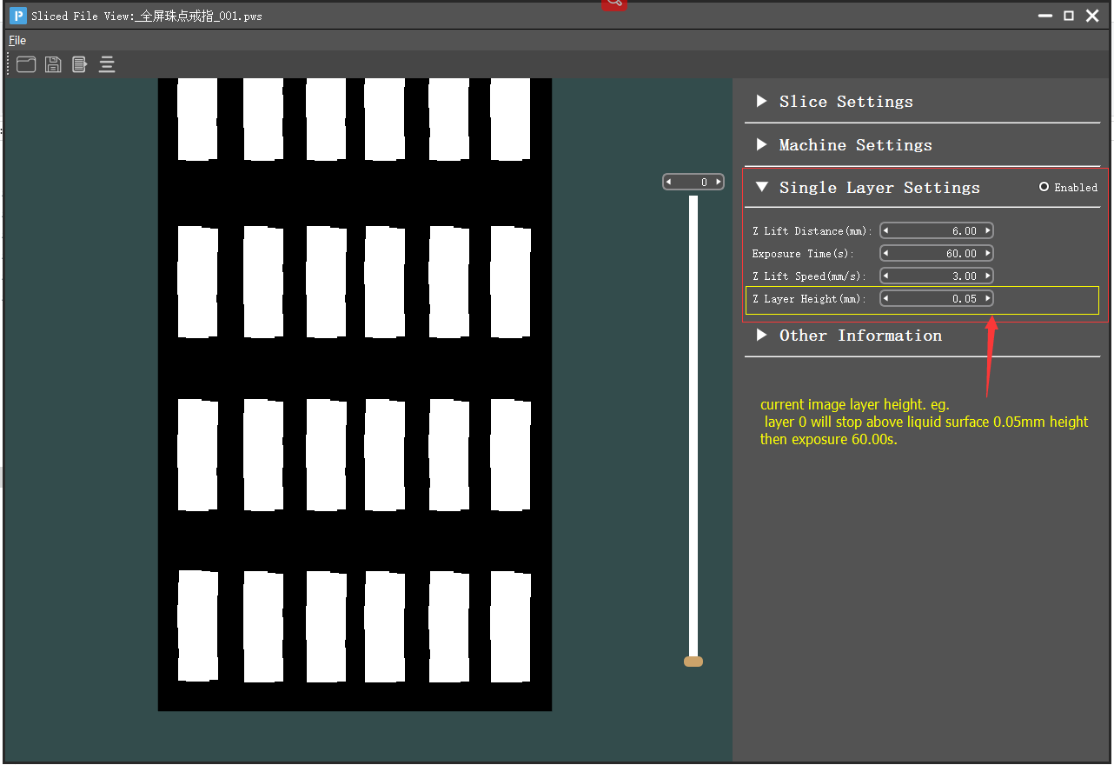

Picture 1

1. Default Sliced pws file is not enabled single layer settings, So please set Enabled radio button.
2. When you ensure all thing done, Then clicked mean “File” => “Save As ...”

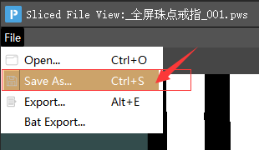

Picture 2

1. Please Update firmware at same time. “P_V341T.bin” is the binary file that you can use individual z layer height feature.
2. So if you changed individual z layer height, the layer height which you set in slice setting parameter no longer valid.

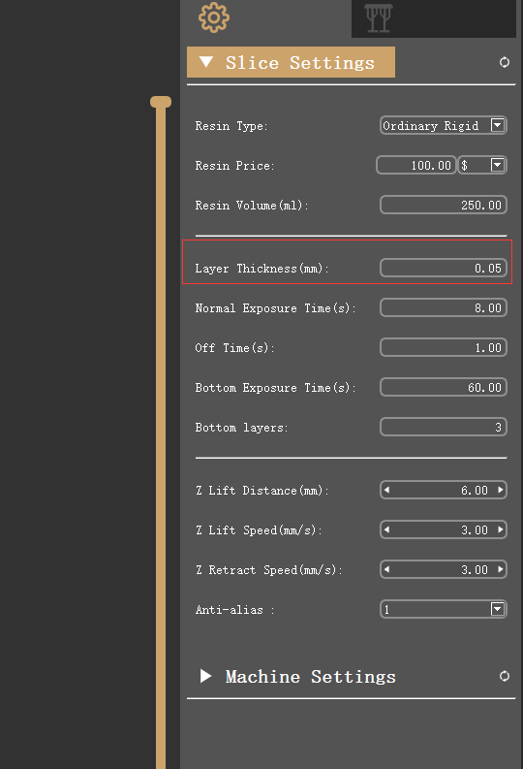

Picture 3